Windows Reboot 1.5

Purpose
With Windows Reboot you can schedule to shut down the system after a specified amount of time. Yes, I know it is not the first application you can find on net that is doing this. It started as a small test for the WinAPI functions and later it grew to become what it is. Was useful to me and I thought it is a good idea to share it.

The main window
The main window of the application is presented in Fig.1.
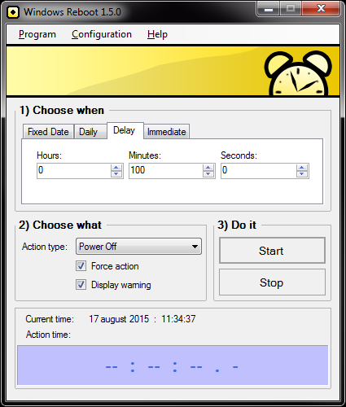
Fig.1 - The main window of the application

To use Windows Reboot you need to make 3 steps:
- Choose when to do the action;
- Choose what action to do;
- Start the timer.

Action time (Choose when)
In the upper part of the window you can chose the time when the action should take place. Chose one of the following options:
- Fixed Date - You can specify a date and time when the action should be executed.
- Daily - You can chose to run the action at the same time every day.
- Delay - You can specify a delay calculated from the moment when you press the “Start Timer” button and after this period of time passes, the action is executed.
- Immediate - The action is executed right when you press the “Start Timer” button.

Action type (Choose what)
The action that can be executed is one of the following:
- Ring - displays a “Ring-Ring” message.
- Lock Computer - Locks the computer. Is similar with the Win + L combination
- Log Off - Logs off the current user.
- Sleep - Puts the system in the sleep state
- Hibernate - Puts the system in the hibernate state
- Reboot - Restarts the system
- Shut Down - Shuts down the system but does not switches off the power
- Power Off -Shuts down the system and switches off the power. This option is not available on older systems that don’t have ATX mother boards.
For all actions except “Ring” and “Lock Computer”, an additional checkbox is available: “Force closing programs”:
- If it is checked, the action is performed immediately;
- If it is not checked, a message is broadcasted to all the running applications, asking permission to perform the action.

Start the timer (Do it)
After you chose the time and the action, press the “Start” button. A timer in the bottom of the window will show you the remaining time until the action will be executed.

The Configuration
In the “Configuration” menu there are four items:
- “Load Settings” – The initial settings are the settings loaded from the configuration file
- “Save Settings” – Saves the current settings to the configuration file.
- “Load Default Settings” – Loads the default values.
- “Options...” – Opens the options panel.
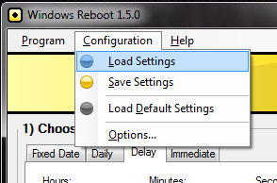
Fig. 2 – The “Configuration” menu
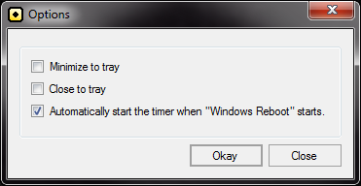
Fig. 3 – The “Options” panel

The tray icon
From the “File” menu you can send the Windows Reboot application to the tray (next to the Windows clock).
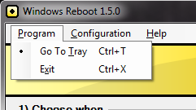
Fig. 4 – The “Go To Tray” menu item.
Left-clicking the tray icon will restore the main window on the screen.
Right-clicking the tray icon will display a menu from where you can choose one of the actions to be performed immediately.
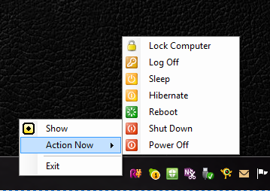
Fig. 5 – The tray icon menu

How To...

...run an action daily
- Put a link to Window Reboot in the Windows’s Startup directory: C:\Users\<user-name>\AppData\Roaming\Microsoft\Windows\Start Menu\Programs\Startup. This will start Windows Reboot when the windows starts.
- Configure Windows Reboot to run daily.
Select Daily tab and chose a time to run.
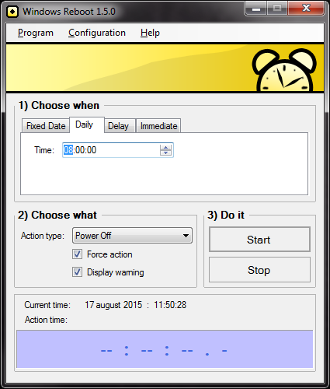
- Save the configuration.
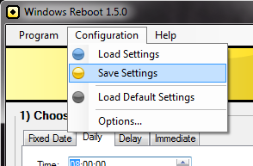
- Change the Options to start the timer immediately after the Windows Reboot starts.
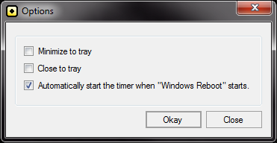
© 2015 Dust in the Wind

